Geoffrey B. Elliott
No Professor Applies
ENGL 1213
9 March 2016
Context to Answer a Question about the Comprehensive Exams for UL Lafayette PhD Students in English
Earning a doctorate in English from the University of Louisiana at Lafayette (ULL) obliged me to sit for a series of comprehensive exams. Like my contemporaries, I had to take four five-hour tests over such areas of inquiry within English studies as English languages and literatures to 1500, early modern English literature, American literature to approximately 1900, and contemporary fantasy literatures in the US and UK. The idea behind such exams, according to how the ULL Department of English describes them on its website as of 23 September 2015, is to facilitate both teaching and continued research, ensuring that students who complete the program adequately reflect the generalist orientation of the program. Yet while the expressed requirements for the exams note that coursework across literary areas and periods must be taken, many of the students in the program are not obliged to range outside of literary studies, and most graduates will teach outside those areas–namely in rhetoric and composition. Why this is so is unclear; such a lack of clarity merits investigation.
Finding out why the PhD program in English at ULL acts as it does prompts looking at peer institutions of that school. The most immediate peers are the other members of the University of Louisiana system, given that they are unified at their higher administrative levels and therefore operate under many of the same constraints and restrictions that will affect ULL. The problem with doing so is that ULL is the only institution in the University of Louisiana system that offers a PhD in English. A slightly less immediate set of peers is the membership of the Sun Belt Conference, the schools against which ULL competes in athletic events; conferences tend to be organized to bring comparable schools into competition, so the member institutions are likely juxtaposed fairly. Too, more of the schools have PhD programs in English than in the University of Louisiana system, offering more useful data for comparison.
In composing the infographic, I sought to connect my presentation to the materials being presented. Consequently, I strove initially to mimic the color scheme and typefaces used by my focal materials, the description of the comprehensive exams hosted by the ULL English Department; the idea therein was that the treatment of the subject would reflect the subject itself. The infographic title was put at the top center to foreground it most prominently. Information was positioned to move from broad to narrow, leading readers down the page along a single center line. Alignment and grouping were seen to via tables, into which the increasingly narrow data-sets were set for ease of reading; while the focal information was placed near the bottom of the infographic, the plethora of earlier information serves to balance the document. Citations follow typical online practice, providing URLs for the materials collected and grouping them under a single heading at the bottom of the page; they need to be present but unobtrusive, and the placement and smaller typeface conduce to that end.

Raw-Form Infographic
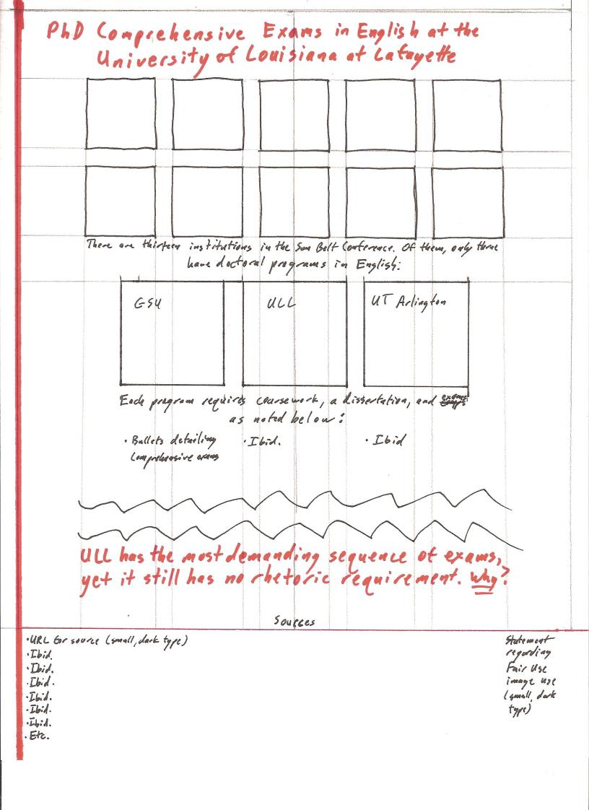
Digital-Original Infographic
